TIK Centre for Technology – annual report 2016
Contents
Letter from the Director 2
TIK – Facts and figures 3
Staff – new faces at TIK. 4
Research 5
Research projects at TIK in 2016 6
Education 8
Master programs 8
Rising number of applicants 8
Priority and quality of applicants 8
Student satisfaction 9
9
Other news in 2016 9
Teknovatøren 9
PhD – doctoral degree 10
Disputations 10
Candidates 11
PhD courses and seminars 13
Research communication 14
TIKs website 14
Social media 14
TIK Talks 14
External media dissemination 15
Seminars and workshops 15
Publications 17
Books 18
Edited Special Issue 18
Publications reported to the Norwegian Science Index (NVI) in 2016: 18
Working Papers on Innovation Studies 20

Letter from the Director

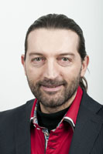
(To be completed after the discussions in the Board)

Fulvio Castellacci, Director

TIK – Facts and figures

The TIK Centre at the University of Oslo was established by the senate (now the University Board) as an independent unit organized under the Faculty of Social Sciences in 1999. This unit was a merge of the former Centre for Technology and Human Values (TMV), the interdisciplinary “European master program in Society, Science and Technology” (ESST) and the Prosjektforum (project forum, which is no longer a part of the centre).
The TIK Centre carries out high quality research, education and research communication in the cross-disciplinary fields of innovation and science and technology studies.

Quick overview of TIK:
Scientific publications per year (2006-2016) | 25
Masterprograms | 2
Courses (Masters and Ph. D. courses) | 12
PhD-students (per 31.12.2016) | 27
Scientific man years (2016 - numbers from DBH, including Centre Director) | 27,75
Administrative man years (2016 - numbers from DBH) | 5,05
Total number of employees (2016 - numbers from DBH) | 32,80
Budget (2017) | 37.5 Million NOK
Percent of the budget that is financed by external grants (2017) | 65%
Research projects with external financing (2016) | 20

Staff – new faces at TIK

Susanne Bauer joined the senior researcher staff as an associate professor from January 2016.
TIK welcomed a total of three new PhD candidates, see complete list of candidates in the program under PhD – Doctoral degree. Two of the new PhDs are employed at TIK: Marie Byskov Lindberg and Henrik Schwabe.
TIK also welcomed the new postdocs Tone Huse and Hilde Reinertsen.
Jord Johan Herheim Nylenna joined the administration, filling in for Lene Angelskår who went on maternity leave from May 2016.
Jørgen Bolligmo also joined TIKs administration, as an executive officer in a part time position.
Ask Greve Jørgensen joined Little Tools as a coordinator
Associate professor Sissel Myklebust retired from her position in March 2016.

Research

Research at the TIK Centre is organized into two research groups: the Science, Technology and Culture research group and the Innovation Studies research group.
TIK’s researchers in the Science, Technology and Culture research group are mainly situated within the multidisciplinary field of Science & Technology Studies (STS), and focuses on the ways in which science and technology are shaped, become institutionalized and become involved in politics. Science and technology are viewed as cultural and material practices that can be fruitfully studied from both historical and contemporary perspectives.
The innovation group focuses on understanding the complex and dynamic relationships between the technological, economic and social factors that contribute to innovation in various firms, sectors, regions and countries. The point of departure for this work is that technological change and learning are important driving forces for societal change.
Both groups are active in international networks and initiatives, including the Peder Saether Centre in Berkeley, EU-SPRI and Nordic STS.
In addition to the two groups, climate and the energy transition is a cross-cutting theme at TIK, encompassing researchers from both groups.
All the researchers at TIK apply for funding from a magnitude of programs and funding agents, but the dominant part of TIKs projects are funded by the Research Council of Norway, either as project coordinators or as partners in projects hosted by other institutions. Following national and university strategic decisions, TIK has also taken steps to ensure further application to, and hopefully funding from, the EU, through the Horizon 2020 Research Program.
Three new projects launched at TIK in 2016. The largest initiative to start in 2016 was the launch of OSIRIS – Oslo Institute for Research on the Impact of Science. The OSIRIS centre has a 75 per cent funding from the Norwegian Research Council through the FORINNPOL-programme, while the last 25 per cent is co-funded between the partners in the centre. Professor Magnus Gulbrandsen is the centre director, with associate professor Taran Thune as vice-director.
The other two new projects are TEMPEST, a new inter-diciplinary project coordinated by the Institute of Transport Economics (TØI). Jan Fagerberg is the senior researcher at TIK, and the employment of a PhD on this project will be completed in the beginning of 2017. The other is Helge Ryggvik’s project on Jernbaneverket - History of the Norwegian government’s agency for railway services 1996-2016. This project had an intensive period of six months of research and writing, concluding with the publishing of a new book, Sporskiftet. Jernbaneverket 1996-2016, right in time for Christmas.
An additional four project applications were approved in 2016, where the projects will commence in 2017 and 2018.

Research projects at TIK in 2016

PROJECT | PROJECT LEADER | STARTING DATE | FUNDING
OSIRIS | Magnus Gulbrandsen | 1-mai-2016 | RCN - FORINNPOL
TEMPEST | Fulvio Castellacci |  | RCN - - via TØI
Jernbaneverket | Helge Ryggvik | 1-apr-2016 | Jernbaneverket
HappyICT - Responsible Innovation and Happiness: A New Approach to the Effects of ICTs | Fulvio Castellacci | 01-des-2015 | RCN - SAMANSVAR
Innovation dynamics within a multinational company: A survey-based study of Telenor | Fulvio Castellacci | 01-okt-2015 | Telenor
ERC StG Little Tools Enacting the Good Economy: Biocapitalization and the little tools of valuation | Kristin Asdal | 01-aug-2015 | EU Horizon 2020 - European Research Council Starting Grant
InGrid - Integration of Power Transmission Grids - Prospects and Challenges at National and European Levels in advancing the energy transition | Allan Dahl Andersen | 01-aug-2015 | RCN - ENERGIX
SusValueWaste - Sustainable path creation for innovative value chains for organic waste products | Fulvio Castellacci | 01-jun-2015 | RCN - BIONÆR - via NIFU
I3U Investigating the Impact of the Innovation Union | Fulvio Castellacci | 01-feb-2015 | EU Horizon 2020 - via Uni. Maastricht
SIVAC - Supplier Industry and Value Creation | Taran Thune | 01-sep-2014 | RCN - PETROSAM 2
Robust regulatory regimes? Defenses against major accidents | Helge Ryggvik | 01-jun-2014 | RCN - PETROMAKS 2 via IRIS
ETIS - Europeanisation of Energy-Technological Innovation Systems: drivers, consequences and strategic challenges for Norway | Olav Wicken | 01-jan-2014 | NFR - ENERGIX via FNI
The IPCC AR5 In Europe: Usability, framing and Communications og Scientific climate information | Göran Sundqvist | 01-jan-2014 | RCN - NORKLIMA - via CICERO
The developmental State reloaded: Brazilian industrial policy in the 21st century | Helge Ryggvik | 01-sep-2013 | RCN - LATINAMERIKA - via NIBR
ELSA - The Aua-Genome Project | Kristin Asdal | 01-sep-2013 | RCN - BIOTEK2021 - via SIFO
CenSES - Centre for Sustaniable Energy Studies | Olav Wicken | 01-feb-2012 | RCN - FME - via NTNU
RFID in Society - preparing for the Internet of things. Researching opportunities and obstacles in RFID innovation | Kristin Asdal | 01-jun-2011 | RCN - VERDIKT - via SIFO
In addition, three PhDs with external funding are included in the total number of external projects in 2016.

Education

Master programs
TIK offers two programs at the master level:
- TIK - Technology, Innovation and Knowledge (2 years)
- ESST - Society, Science and Technology in Europe (1,5 years)

Rising number of applicants
30 master students are admitted in total every year, usually 20 TIK students and 10 ESST students. We have experienced a rise in applicants for the past few years, mostly to the TIK program.

Priority and quality of applicants
Students can apply to a maximum of three UiO programs any given year, and they must make a priority list. In 2015, around 100 of the applicants had TIK/ESST as their number one priority. In 2016 this had risen to 130, and so far in 2017 there are 139 1st priority applicants. Also, the grade point average (GPA) of applicants has been rising gradually since 2013. The GPA of admitted students in 2016 varied between B- and A.
Both of these developments are positive, and are expected to increase the quality of students that will enroll in TIK’s Master programmes in the coming years.

Student satisfaction
Studiebarometeret.no - a web portal made by NOKUT - for 2016 shows that TIK students are generally happy with their programme. Students are particularly happy with the types of exams they have, the academic environment and contact between students and staff. The ESST programme received slightly less favourable reviews (source: Studiebarometeret.no).

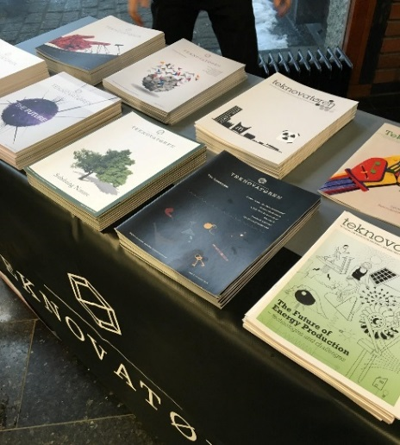
Teknovatøren
Teknovatøren is the TIK and ESST students’ semi-scientific student magazine. It is partly financed by the TIK centre. In 2016, Teknovatøren celebrated its 10th issue.
Editions in 2016:
- #10 Human performance
- #11Crossing Borders

Other news in 2016
- Fulvio Castellacci substitutes as master coordinator in 2016.
- The first semester course has been updated and partly reorganized. A new module on methods was taught in the autumn 2016 as part of the new fall semester course.
- Grades (A-F) were introduced to the courses TIK4011, TIK4021 and TIK4001, going into effect from the autumn semester 2017.
- Theses submitted 6 ESST, 12 TIK.
- Winners of the “students vs employees” football match: Staffletico!

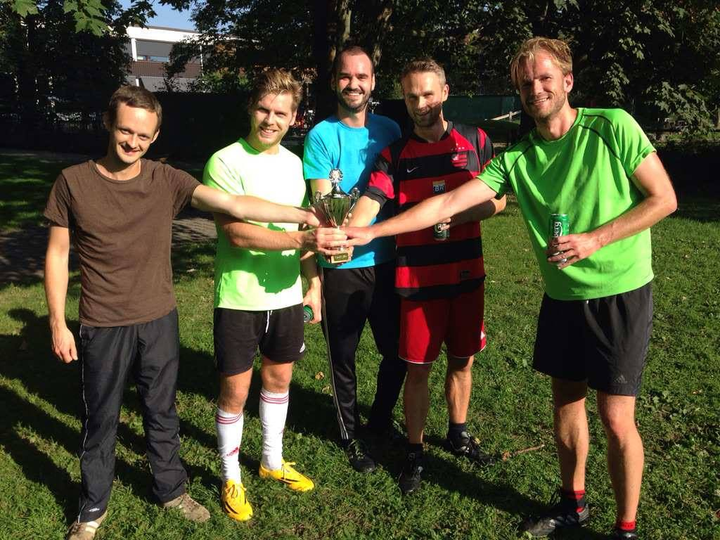

PhD – doctoral degree

The TIK departmental doctoral study plan in Technology, Innovation and Culture is one of seven study plans within the doctoral program that is offered by the Faculty of Social Sciences at UiO. The TIK program aims to provide both research training and a broad base of advanced knowledge in theoretical and methodological approaches within STS and innovation studies.
An evaluation of the entire PhD program at the Faculty of Social Sciences was conducted by an external panel in the Autumn of 2016. The evaluation committee’s primary task was to evaluate the scientific quality of the program and all seven tracks, including TIK, in light of international standards and the efficiency of the program.
The general evaluation from the committee was positive, though some recommendations for furthering quality in the program and in the different tracks were given. Follow-up of recommendations and further quality assessment will continue during 2017.
********
TIK would also like to express our condolences to the family of former PhD candidate Kjetil Olaussen, who sadly passed away in 2016.
********

Disputations
Two candidates successfully defended their thesis for the degree of PhD, and one candidate successfully defended her thesis for the Dr.Philos in 2016:
Candidate | Date | Thesis title | Supervisors | Committee
Hilde Reinertsen | 27.4.2016 | Optics of Evaluation. Making Norwegian foreign aid an evaluable object, 1980-1992 | Kristin Asdal, TIK, and Gabrielle Hecht, University of Michigan | Bernike Pasveer, Matthew Hull and Göran Sundqvist
Thi Bich Ha Pham | 18.11.2016 | Building and Transforming Dominant Technology. The Portland cement industry | Olav Wicken, TIK, and Keith Smith, Imperial College | Maureen McKelvey, Birgitte Gregersen and Erling Holden
Mari Ratinen, Dr.Philos. | 2.12.206 | Social construction of niche development toward sustainability transitions. Examples from wind energy and photovoltaics |  | Andrew Stirling, Mikko Jalas and Taran Thune

Another two candidates, Håkon Endresen Normann and Hilde Nykamp, submitted their thesis for evaluation in 2016.

Candidates
TIK welcomed three new PhDs in 2016, and had a total of 27 candidates enlisted in the program as of December 31st 2016:
Candidate | PhD project | Supervisor(s) | Funding
Bianca Cavicchi | Governance of bioenergy innovation systems in the rural areas of Emilia Romagna and Oppland-Hedmark. | Olav Wicken, John Bryden | NILF
Simen Gangnæs Enger | Factors affecting organisations' ability to participate and achieve EU-funding: Evidence from the Norwegian R&D sector. | Fulvio Castellacci, Magnus Gulbrandsen, samt mentor i KD Geir Arnulf | NFR/KD - offentligPhD
Morten Fosaas | Innovation Systems and Innovation Policy: Perspectives and Challenges | Jan Fagerberg og Anna Bergek | TIK - basis
Jakoba Sraml González | Creativity and the innovation process in small and medium firms during financial and economic  turmoil: An ethnographic study | Magnus Gulbrandsen | TIK - basis
Sveinung Grimsby | How does the Norwegian food industry act during innovation processes? A study on new  product failure rate and systematic differences between successful and unsuccessful innovation projects in the food industry. | Magnus Gulbrandsen og Cathrine Finne Kure | Nofima AS
Hanne-Stine Hallingby | Modularization and dynamics in the mobile ecosystem | Magnus Gulbrandsen og Patrick Waldemar | Telenor/NFR - næringsPhD
Erlend A.T. Hermansen | The climate science-policy nexus revisited | Göran Sundqvist og Hege Westskog | CICERO
Bård Hobæk | Salmon Sustainabilities | Kristin Asdal | TIK – strategisk
Ásdis Jónsdottir | Climate change,ecology and knowledge in Iceland: An anthropological study. | Tian Sørhaug og Gisli Palsson | TIK - basis
Christine Mee Lie | R&D Policy and green growth in East Asia | Jan Fagerberg | TIK - basis
Marie Byskov Lindberg  New candidate in 2016 | The politics of power transmission | Allan Dah Andersen | TIK – prosjekt - InGrid
Sylvia Lysgård | Hva dreier det segom? Næringsliv, politikk og praksiser i to norske (miljø)saker | Göran Sundqvist og Kristin Asdal | TIK - basis
Turid Markussen | Antropologi I nord | John Law | Senter for kvinne- og kjønnsforskning (nå: STK)
Tuukka Mäkitie | Function-interactions in innovation processes:  the technological innovation system of petroleum industry | Taran Thune | TIK - basis
Håkon Endresen Normann  Thesis submitted in 2016 | How can we explain the R&D driven innovation policy towards renewable energy technologies in  Norway, through the example of offshore wind power? | Olav Wicken | TIK - CenSES
Hilde Nykamp  Thesis submitted in 2016 | Green Innovation in the Norwegian Construction Industry | Magnus Gulbrandsen | TIK - basis
Helena Nynäs | Valuation of major waterfalls in modern Norway | Sissel Myklebust og Mari Hvattum | NVE
Artur Santoalha | Smart Specialization: Where do European regions stand? | Fulvio Castellacci | TIK - strategisk
Henrik Schwabe  New candidate in 2016 | ICTs and Subjective Well-Being: Perceived fairness, social mobility and capabilities | Fulvio Castellacci | TIK – prosjekt_ Happy ICT
Erlend Osland Simensen | Mapping the supplier industry | Taran Thune | TIK – prosjekt: SIVAC
Guro Ådnegard Skarstad | New Fish in a New Environment: Challenges to a Comprehensive Management of Fish,  Environments and Human Beings. | Kristin Asdal | NILF
Kari-Elisabeth Vambeseth Skogen  New candidate in 2016 | The impact of research on policy: an empirical study of the use of scientific knowledge in policymaking in Norway | Taran Thune, Magnus Gulbrandsen, samt mentor i KD Geir Arnulf | NFR/KD - offentligPhD
Hege Rudi Standal | Universities as Strategic Actors- University management and the new era of Governance. | Magnus Gulbrandsen og Merle Jacob | TIK - basis
Nhat Strøm-Andersen | Towards a sustainable bioeconomy: The role of dynamic interplay between technology, industry and  policy - a study of omanic waste streams from the Norwegian food industry | Fulvio Castellacci | TIK – prosjekt: SusValueWaste
Kasper Rogde Søyland | An Innovative Century? The origins for advanced aluminium prefabrication | Olav Wicken og Finn Ørstavik | HBV
Tina Naomi Talleraas | Unlocking the Black Box of Nuclear Disarmament:  A case study of the Norwegian initiative to re-politicize the bomb | Göran Sundqvist | TIK - basis
Irene Øvstebø Tvedten | Science and Corporate Policy —DNV GL as an enabler for a sustainable future" | Kristin Asdal /Susanne Bauer | TIK - basis

PhD courses and seminars

TIK 9022 Economics of Innovation: Course given as part of NORSI, the national research school in innovation. This is the second time the course was offered, the first time in 2014. 11 candidates from national and international institutions participated, and 10 candidates submitted a final course paper for course accreditation. More information about the course: https://www.uio.no/studier/emner/sv/tik/TIK9022/index-eng.html
TIK9023 Understanding technological and industrial transformation processes: This week-long course was offered for the first time in 2016, developed from the research done in the SIVAC-project, funded by the Research Council of Norway. 12 national and international candidates participated. More information about the course: http://www.uio.no/studier/emner/sv/tik/TIK9023/
TIK9101 Obligatory PhD seminars: Internal PhD seminars for TIK candidates were held in both the Spring and Autumn semester, at Tøyen Hovedgård. In addition, four candidates had their midway evaluation seminar during 2016, and three candidates had their final dissertation seminar before thesis submission.
TIKs candidates continue to benefit from TIK being involved in national and international research networks like EU-SPRI, EASST – European Association for the Study of Science and Technology, and the Norwegian Research School on Innovation (NORSI), giving access to a large number of research courses and relevant conferences.

Research communication

Research communication

TIKs website
During 2016, the following research based news article was produced for TIKs web page:
- Strenge rapporteringskrav kan tåkeleggje bistandsresultat
This article was based on Hilde Reinertsen’s PhD project, and written at the time of her thesis defence in 2016.
In addition, 21 shorter news articles (Aktuelle saker) were written and published online. TIK's web page has between 700-1200 visitors per month.

Social media
TIK has been on Twitter since 2012, and on Facebook since 2015. The facebook page has around 400 followers, and mainly targets potential applicants for the master and phd programs.
We publish news, events, publications, available positions, TIK Talks, student information etc. The most popular posts have reached over 7000 facebook users.

External media dissemination
TIK researchers regularly appear in the media. In 2016, 12 media articles, comments, opinion pieces etc by TIK researchers were cited on TIK’s web page. Shorter quotes are not included.
TIK would particularly like to note that Hilde Reinertsen gained much publicity for her PhD project on foreign aid, appearing in Dagens Næringsliv, Morgenbladet, Bistandsaktuelt etc.

Internal seminars and workshops at TIK in 2016

Date | Speaker | Title
20.12.2016 | Tuukka Mäkitie | Midway seminar: Relatedness as a resource
06.12.2016 | Thomas Lemke | An Alternative Model of Politics? Perspectives and Problems of Jane Bennett’s Vital Materialism
05.12.2016 | Little Tools team | Workshop: Versions of biopolitics/Versions of Foucault
2.12.2016 | Mari Ratinen | PhD thesis defence
30.11.2016 | Andrew Stirling | Emancipating Transformations: from Anthropocene control to democratic care for the Earth
21.11.2016 | Christine Mee Lie | Final dissertation seminar: Christine Mee Lie
18.11.2016 | Ha Pham | PhD thesis defence
8.11.2016 | Piergiuseppe Morone | Changing paradigms - Making the transition towards a bio-based economy possible
2.11.2016 | Sarah Blacker | Making Traditional Knowledge Matter: Environmental Contamination, Indigenous Health, and Oil Production in Canada
26.10.2016 | Kristin Asdal | Kvalitativt metodeforum om dokumentanalyse
13.10.2016 | Magnus Gulbrandsen & more | OSIRIS launch seminar
9.09.2016 | Tone Druglitrø | Trial lecture: “What is Science and Technology Studies (STS)? Where does it come from, to where is it moving and why should we care?"
9.09.2016 | Ana Delgado | Trial lecture: “What is Science and Technology Studies (STS)? Where does it come from, to where is it moving and why should we care?"
7.09.2016 | Govert Valkenburg | Trial lecture: “What is Science and Technology Studies (STS)? Where does it come from, to where is it moving and why should we care?"
7.09.2016 | Maria F. Olarte-Sierra | Trial lecture: “What is Science and Technology Studies (STS)? Where does it come from, to where is it moving and why should we care?"
31.08.2016 | Little Tools team | Valuation studies on 4S/EASST 2016
1.06.2016 | John Dean | Internationalisation of small and medium sized companies: The Australian Experience.
30.05.2016 | Happy-ICT team | The Effects of ICT's on Well-being
4.05.2016 | Bianca Cavicchi | Midway seminar
29.04.2016 | Little Tools team | Little Tools workshop: The sites of documents
28.05.2016 | Matthwe Hull | Satisfied callers: police, corporations, and documentation in India
28.04.2016 | Håkon Normann | Final dissertation seminar
27.04.2016 | Hilde Reinertsen | PhD thesis defence
13.04.2016 | Jen Plahte | Proposals for new incentives and reward models for stimulating antibiotics innovation
1.04.2016 | Hanne-Stine Hallingby | Midway seminar
14.03.2016 | Mats Frilund | The 9/11-effect on engineering research
3.03.2016 | Sissel Myklebust & more | Final Seminar: Sissel Myklebust
4.02.2016 | Ha Thi Bich Pham | Final dissertation seminar: Ha Thi Bich Pham
13.01.2016 | Claes-Fredrik Helgesson | Valuography as a new way to (re-)visit the lab as well as the restaurant?
8.01.2016 | Jakoba Sraml Gonzalez | Organisational creativity and innovation in challenging situations

Publications

2016 has been a good year for TIK in regards to scientific publications. 22 scientific articles has been published by both junior and senior researchers in prestigious journals, such as Research Policy and Technological forecasting & social change. One book has been edited by one of our junior researchers and three book chapters has been published, all on Routledge.
The total number of publications are 27, where 3 are level two publications. This is a reduction compared to 2015, which was a very good year in terms of publication (36 in total). 27 publications maintains a high level of publications after a top year. The history of publications shows that previous years after a top year have had a more significant drop in publications.
The graph below shows TIKs number of scientific publications in the period 2005-2016:

The continued high number of publications might be a result of TIK’s new policy of granting an extra allowance to researchers with a certain level of publications.
Converting the publications to publications points, 2016 gave 27,3 points. The graph below shows TIKs publication points in the period 2005-2016:

In 2015 a new formula for the national publication indicator was introduced in with the aim of closing the gap between the scientific domains. With the old indicator, the Social Sciences and Humanities gained more publication points relative to the Natural Sciences, based in a more traditional publication strategy, where one or just a few authors write monographs. The new indicator is set to even the field, emphasizing, among other things, international cooperation.

Books

Bjørkdahl, Kristian and Druglitrø, Tone. Animal Housing and Human-Animal Relations. Politics, Practices and Infrastructures. London, Routledge, 2016 (ISBN- 978-1-138-85411) 216 p.
Ryggvik, Helge. Sporskiftet. Jernbaneverket 1996-2016. Forlaget Press 2016 (ISBN 978-82-328-0121-3) 391 p

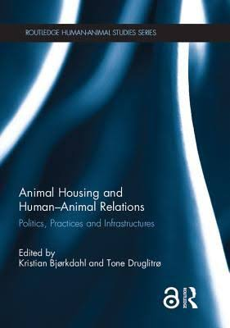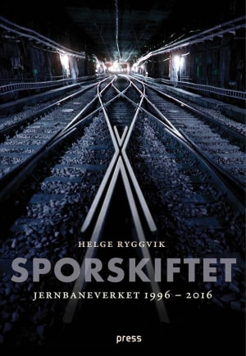

Edited Special Issue
Research Policy – Special Section on Hospitals and Innovation. 2016. Vol. 45, No 8.

Publications reported to the Norwegian Science Index (NVI) in 2016:

Ferrari, Annalisa; Morone, Piergiuseppe; Tartiu, Valentina Elena.
Tackling uncertainty through business plan analysis—A case study on citrus waste valorisation in the south of Italy. Agriculture 2016 ;Volum 6.(1)

Morone, Piergiuseppe; Morone, Piergiuseppe; Lopolito, Antonio; Lopolito, Antonio; Anguilano, Daniela; Anguilano, Daniela; Sica,
Edgardo; Sica, Edgardo; Tartiu, Valentina Elena.
Unpacking landscape pressures on socio-technical regimes: Insights on the urban waste management system. Environmental Innovation and Societal Transitions 2016 ;Volum 20. s.62-74

Andersen, Allan Dahl; Andersen, Per Dannemand.
Foresighting for inclusive development. Technological forecasting & social change 2016

Asdal, Kristin; Hobæk, Bård.
Assembling the Whale: Parliaments in the Politics of Nature. Science as Culture 2016 ;Volum 25.(1) s.96-116

Bauer, Susanne.
'Persönlichkeitsanalyse' als akademische Inwertsetzung. Zeitschrift für medienwissenschaft 2016 ;Volum 2. s.160-165

Bjørkdahl, Kristian; Druglitrø, Tone.
Animal Housing/Housing Animals: Nodes of politics, practices and infrastructures. I: Animal Housing and Human-Animal Relations: Politics, Practices and Infrastructures. Routledge 2016 ISBN 9781138854116. s.1-14

Bugge, Markus; Thune, Taran Mari.
Situated Knowledge Spillovers: A Case Study of Industry Specificity in Urban Knowledge Sourcing. Geografiska Annaler. Series B. Human Geography 2016 ;Volum 98.(3) s.255-270

Børing, Pål; Fevolden, Arne Martin; Herstad, Sverre Johan.
Eager and able: A study of innovation activity among young, mature and old firms in Norway. Economics Bulletin 2016 ;Volum 36.(1) s.291-297

Castellacci, Fulvio; Natera, Jose Miguel.
Innovation, absorptive capacity and growth heterogeneity: Development paths in Latin America 1970-2010. Structural Change and Economic Dynamics 2016 ;Volum 37. s.27-42

Cavicchi, Biancha.
Sustainability that backfires: the case of biogas in Emilia Romagna. Environmental Innovation and Societal Transitions 2016 ;Volum 21. s.13-27

Davies, Gail F.; Greenhough, Beth J.; Hobson-West, Pru; Kirk, Robert G.W.; Applebee, Ken; Bellingan, Laura C.; Berdoy, Manuel;
Buller, Henry; Cassaday, Helen J.; Davies, Keith; Diefenbacher, Daniela; Druglitrø, Tone; Escobar, Maria Paula; Friese, Carrie;
Herrmann, Kathrin; Hinterberger, Amy; Jarrett, Wendy J.; Jayne, Kimberley; Johnson, Adam M.; Johnson, Elizabeth R; Konold, Timm;
Leach, Matthew C.; Leonelli, Sabina; Lewis, David I; Lilley, Elliot J; Longridge, Emma R.; McLeod, Carmen M.; Miele, Mara; Nelson,
Nicole C.; Ormandy, Elisabeth H.; Pallett, Helen; Poort, Lonneke; Pound, Pandora; Ramsden, Edmund; Roe, Emma; Scalway, Helen;
Schrader, Astrid; Scotton, Chris J.; Scudamore, Cheryl L.; Smith, Jane A.; Whitfield, Lucy; Wolfensohn, Sarah.
Developing a collaborative agenda for humanities and social scientific research on laboratory animal science and welfare. PLoS ONE 2016;Volum 11:e0158751.(7)

Druglitrø, Tone.
Care and tinkering in the animal house. Conditioning monkeys for poliomyelitis research and public health work. I: Animal Housing and Human-Animal Relations: Politics, Practices and Infrastructures. Routledge 2016 ISBN 9781138854116. s.151-166

Enger, Simen; Castellacci, Fulvio.
Who gets Horizon 2020 research grants? Propensity to apply and probability to succeed in a two-step analysis. Scientometrics 2016 ;Volum
109.(3) s.1611-1638

Fagerberg, Jan.
Innovation Policy: Rationales, Lessons and Challenges. Journal of economic surveys (Print) 2016
Fagerberg, Jan.
Innovation systems and policy: A tale of three countries. Stato e Mercato 2016 (106) s.13-40

Fagerberg, Jan; Srholec, Martin.
Global dynamics, capabilities and the crisis. Journal of evolutionary economics 2016 ;Volum 16.(4) s.765-784

Fevolden, Arne Martin; Tvetbråten, Kari.
Defence industrial policy – a sound security strategy or an economic fallacy?. Defence Studies 2016 ;Volum 16.(2) s.176-192

Gjefsen, Mads Dahl.
Crafting the expert-advocate: training and recruitment efforts in the carbon dioxide capture and storage community. Innovation. The European Journal of Social Sciences 2016

Gulbrandsen, Magnus; Benneworth, Paul; Hazelkorn, Ellen.
The Impact and Future of Arts and Humanities Research. Palgrave Macmillan 2016 (ISBN 978-1-137-40898-3) 220 s.

Hallingby, Hanne Kristine.
Key success factors for a growing technology innovation system based on SMS Application-to-Person in Norway. Technology Analysis & Strategic Management 2016 ;Volum 28.(10) s.1123-1137

Mignon, Ingrid; Bergek, Anna.
Investments in renewable electricity production: The importance of policy revisited. Renewable Energy 2016 ;Volum 88. s.307-316

Piirainen, Kalle Artturi; Andersen, Allan Dahl; Andersen, Per Dannemand.
Foresight and the third mission of universities: the case for innovation system foresight. Foresight 2016 ;Volum 18.(1) s.24-40

Thune, Taran Mari; Mina, Andrea.
Hospitals as innovators in the health-care system: A literature review and research agenda. Research Policy 2016 ;Volum 45.(8) s.1545-1557

Thune, Taran Mari; Reymert, Ingvild; Gulbrandsen, Magnus; Aamodt, Per O.
Universities and external engagement activities: Particular profiles for particular universities?. Science and Public Policy 2016 ;Volum 43.(6) s.774-786

Wicken, Olav.
Industrial Diversification Proceses and Strategies in an Oil Economy: Norway. I: Economic Diversification Policies in Natural Resource Rich Economies. Routledge 2016 ISBN 978-1138958883. s.295-323

Working Papers on Innovation Studies

New Indicators of Smart Specialization: A related diversification approach applied to European Regions
by Artur Santoalha

Innovation in hospitals: piloting a tool for investigating contributions of hospital employees to innovation
by Taran Thune & Magnus Gulbrandsen

The impact of tensions on partnership development: a study of research and innovation partnerships in life science
by Taran Thune & Magnus Gulbrandsen

Combining knowledge to generate new ideas. A study of disclosed ideas for life science inventions
by Taran Thune & Magnus Gulbrandsen
Established sectors expediting clean technology industries? The Norwegian oil and gas sector's influence on offshore wind power
by Tuukka Mäkitie & Allan D. Andersen & Jens Hanson & Håkon E. Normann & Taran M. Thune

Innovation Policy: What, Why & How
by Jakob Edler & Jan Fagerberg

Natural resource knowledge idiosyncrasy, innovation, industry dynamics, and sustainability
by Allan Dahl Andersen & Olav Wicken

Policy networks in energy transitions: The cases of carbon capture and storage and offshore wind in Norway
by Håkon Endresen Normann
Do ‘green’ employment effects vary across industries? Implications for green growth
by Christine Mee Lie

The Effects of ICTs on Well-being: A Survey and a Theoretical Framework
by Fulvio Castellacci & Vegard Tveito

A Taxonomy Of Green Innovators:Empirical Evidence From South Korea
by Fulvio Castellacci & Christine Mee Lie

How Does Innovation Differ across Business Functions? Employee-level Analysis of a Multinational Company
by Fulvio Castellacci & Magnus Gulbrandsen & Jarle Hildrum & E. Martinkenaite & Erlend Simensen & Vegard Tveito

Path creation through branching and transfer of complementary resources: the role of established industries for new renewable energy technologies
by Jens Hanson & Markus Steen & Tyson Weaver & Håkon E. Normann & Gard H. Hansen

Innovation systems and policy: A tale of three countries
by Jan Fagerberg

Who gets Horizon 2020 research grants? Propensity to apply and probability to succeed in a two-step analysis
by Simen G. Enger & Fulvio Castellacci

Foresighting for Inclusive Development
by Allan Dahl Andersen & Per Dannemand Andersen

Actual administrative years at TIK for 2015 is closer to 3,75. Admin at 3,25). There are three full time administrative positions, as well as two part time executive officers (0,75 man years total). The number also includes an adviser hired on an externally funded project.

